Reports - Design Specification & Functional Documentation

Document Name: Reports - Design Specification & Functional Documentation
Version: v1.0
Prepared By: Engineering Team
Date: 05-01-2026
Status: Approved

1. Purpose
The Reports Module provides a visual representation of each ticket’s lifecycle in the form of a horizontal timeline bar graph. This report enables users to understand how time is consumed from ticket creation through assignment and across all milestones within a selected date range.

2. Scope
- Visualize ticket journey in a timeline / bar graph format
- Display time distribution across milestones
- Allow users to filter tickets by Start Date and End Date
- Provide high-level visibility into ticket progress and priority

3. Actors & Roles
3.1 User (Admin / Manager/ Technician)
- Views ticket timelines
- Applies date range filters
- Analyzes ticket progress and delays
- Reviews milestone-wise time consumption

4. Navigation & Entry Point
- Module Name: Reports
- Accessible from the top navigation bar
- Default landing view: Ticket Timeline Report
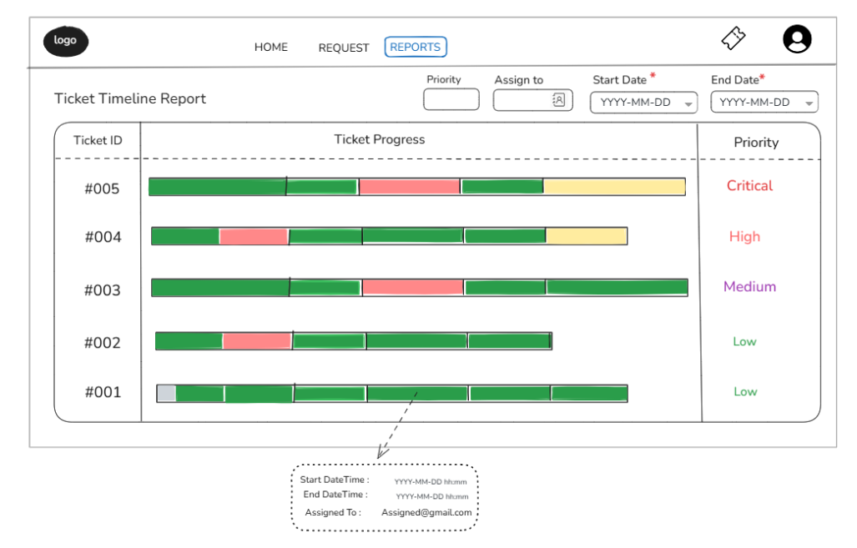

5. Filters & Controls
The Reports module provides multiple filters to refine ticket timeline visibility based on time range, ownership, and priority.
5.1 Date Range Filter
Field |  | Description
Start Date | Beginning of reporting period (YYYY-MM-DD)
End Date | End of reporting period (YYYY-MM-DD)
Date Range Rules
- Both Start Date and End Date are mandatory
- End Date cannot be earlier than Start Date
- Tickets that are opened at any point within the selected date range are included in the report

5.2 Assign To (Resolved By) Filter
Field |  | Description
Assign To | User selection dropdown
Functional Rules
- The filter represents the user who last handled or resolved the ticket
- If a ticket is resolved, the selected user is treated as Resolved By, and the ticket status is Closed
- If a ticket is still open, the filter reflects the current assignee
Multi-User Handling Rule
- If multiple users have worked on the same ticket:
  - Tickets are included the user was the final assignee

5.3 Priority Filter
Field | Description
Priority | Critical / High / Medium / Low
Functional Rules
- Users can filter tickets by one or more priority values
- Priority filter works in combination with Date Range and Assign To filters

6. Report Layout Structure
6.1 Report Table Sections
The report layout is divided into three primary columns:
- Ticket ID Column
- Ticket Progress (Timeline Bar Graph)
- Priority Column

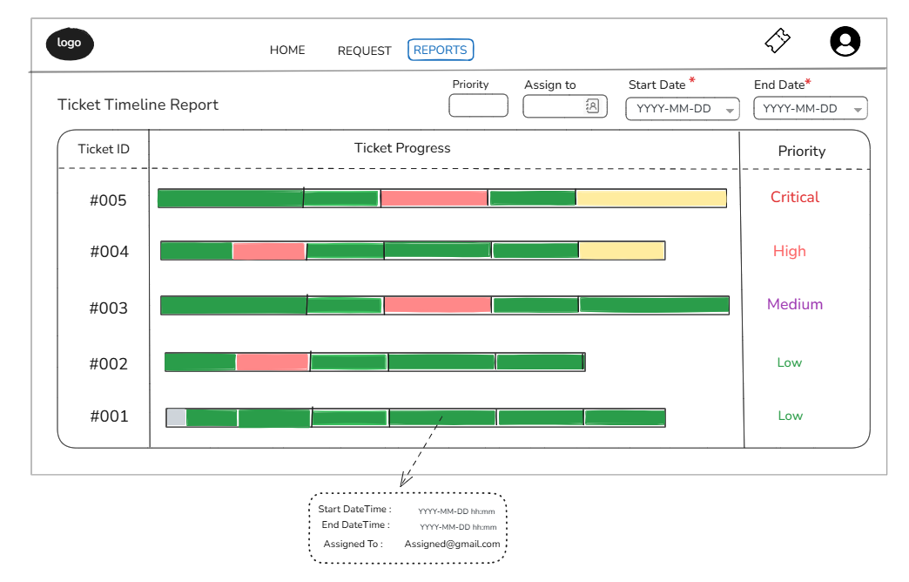

7. Ticket Timeline Visualization
7.1 Horizontal Timeline Bar
- Each ticket is represented by a single horizontal bar
- The bar spans from ticket creation time to the latest milestone activity within the selected date range
- Timeline bars are aligned vertically for easy comparison
- Timeline bars are arranged in a reverse chronological order from top to bottom.

7.2 Milestone Components within Timeline
- Each timeline bar is composed of multiple smaller milestone segments
- Each segment represents a distinct phase of the ticket lifecycle

7.3 Milestone Visualization Rules
- Each milestone is displayed as a colored block within the timeline bar
- Width of each block is proportional to the time spent in that milestone
- Milestones are arranged chronologically from left to right
7.4. Status and Colour Encoding
Milestone block use colour to convey execution status:
COLOR | sTATUS
GrEEN | Completed within deadline
Yellow | In progress
Red | Deadline missed

8. Tooltip & Interaction Behaviour
8.1 Hover Interaction
- On hovering over any milestone segment, a tooltip is displayed
8.2 Tooltip Details
Field | Description
Start DateTime | Milestone start timestamp
End DateTime | Milestone end timestamp
Assigned To | User responsible for that milestone

9. Priority Display
9.1 Priority Column
- Ticket priority is displayed on the right side of the report
- Priority values include:
  - Critical
  - High
  - Medium
  - Low
9.2 Visual Differentiation
- Priority is shown using distinct text colours for quick identification
- Priority value remains static and does not affect timeline length

10. Audit & Traceability
- Timeline data is derived from system audit logs and milestone history
- No data modification is allowed from the Reports module

10. Summary
The Reports module delivers a clear, visual, and time-based representation of ticket journeys using horizontal timeline bar graphs. By breaking down each ticket into milestone components, the report enables users and managers to quickly identify delays, workload distribution, and overall ticket progress within a selected time window.

